# Deployment on IBM Bluemix

## Microservices deployment - including registry center

* Registry Center
  + The code is included in the yp_server folder. It can also be accessed by Github and we highly recommend using the bluemix tool called Delivery_Pipeline.
  + Firstly, a toolchain is required to contain all the services and the registry center.
  + At the same time, we need to create an application in the dashboard of bluemix in order to finish the following steps.
  + Next, create a github tool to pull the code in order to continue with the build stage. Command line should be included in the build script part.

*#!/bin/bash*

*export JAVA_HOME=~/java8*

*mvn -B package*

* + Then we move to the deploy step by configuring with command lines shown below.

*#!/bin/bash*

*#recent log*

*cf logs yp_server --recent*

*cf push "${CF_APP}" -p yp_server-0.0.1-SNAPSHOT.jar -n yp_server -m 256M*

* + Finally, we just need to run the build stage to test the application because the deploy stage will run as soon as the previous stage ends.
* Microservices and Eureka Gateway
  + All these deployments are similar with the steps in deploying Registry Center.
  + But some changes are needed in the deploy stage.
  + The command lines are shown below.

*#!/bin/bash*

*cf push "${CF_APP}" -p "${CF_APP}"-0.0.1-SNAPSHOT.jar -m 256M --no-start*

*cf set-env "${CF_APP}" SPRING_PROFILES_ACTIVE cloud*

*cf start "${CF_APP}"*

* Node.js - Gateway & Authentication app
  + Github URLs:
    - Gateway: <https://github.com/vatsal2210/western-software-microservice-gateway>
    - Auth: <https://github.com/vatsal2210/western-software-microservice-auth>
  + Download the code.
  + Run `npm install`
  + run `npm start` to start all the services.
  + On Bluemix:
    - Step1: Create a toolchain with `Build your own toolchain`
    - Step2: Add tools - Github + Delivery pipeline
    - Step3: Github configuration as below:

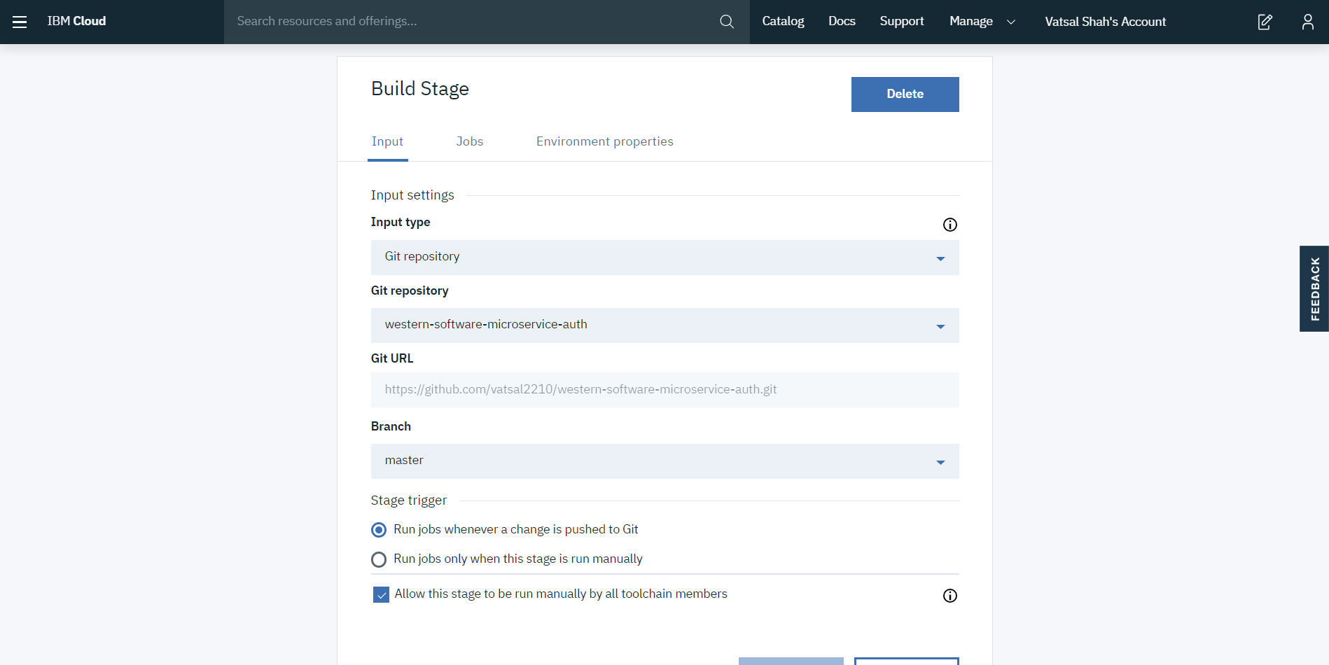

* + - Step4: Delivery pipeline: Create two stage: Build & Deploy
    - Step5: Build stage configuraiton as below:

(I)

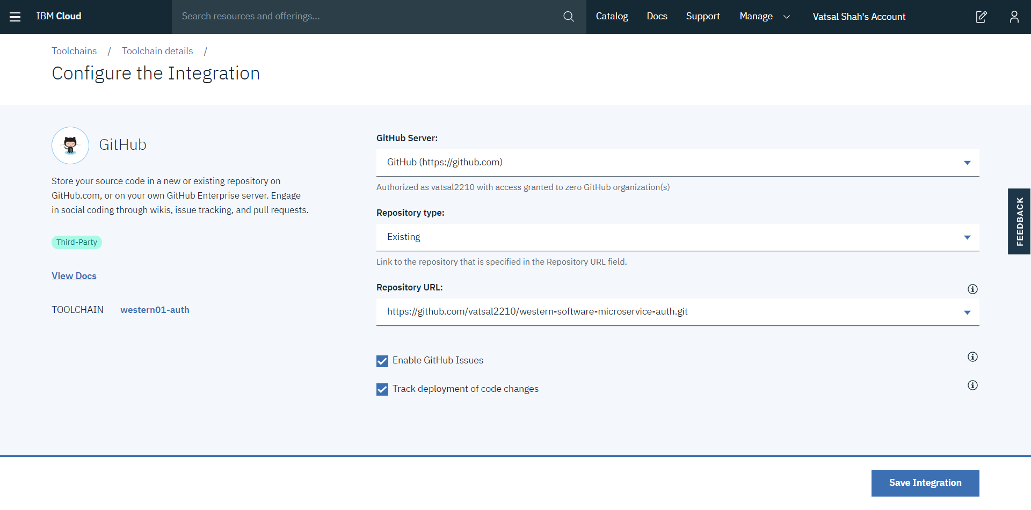

(II)

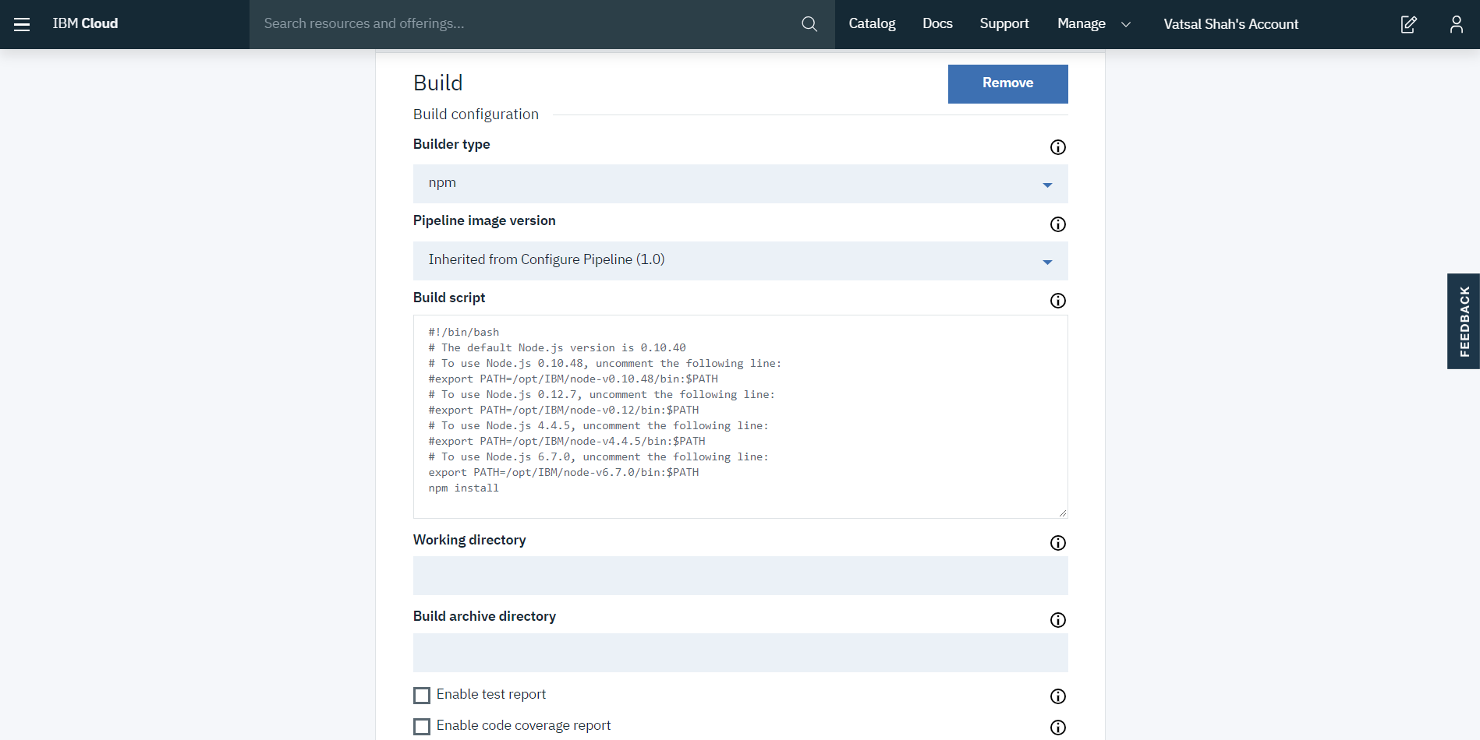

* + - Step6: Deploystage configuraiton as below:

(I)

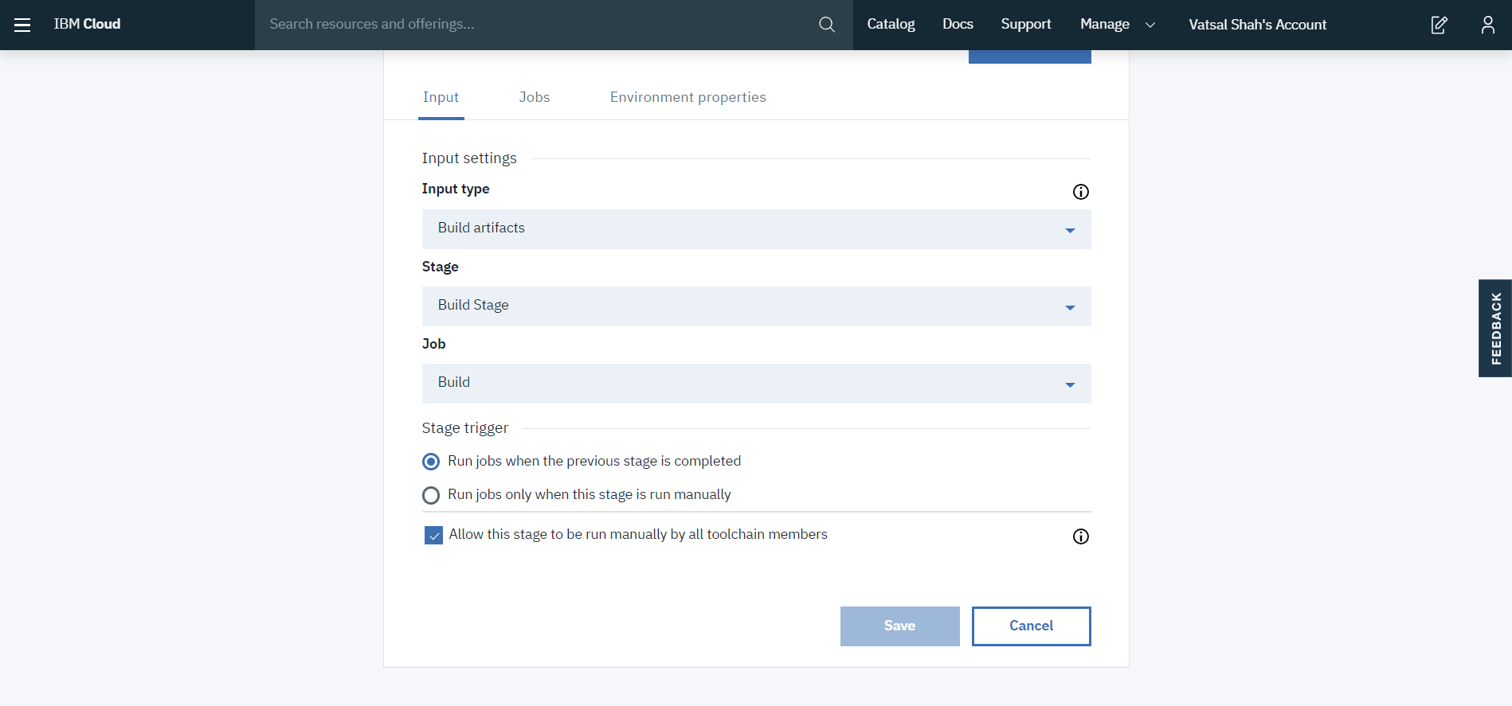

(II)

